

OCC: SOFTWARE DEVELOPER

YEAR 1

SAQA ID 118707

NQF 5

WEB DEVELOPMENT

WEB512

Friday Practical Activity

Table of Contents

Declaration of authenticity 3

Qualification AND ASSESSMENT Details 3

Scenario: CTU Training Solutions Website Homepage Redesign 5

# Declaration of authenticity

I (FULL NAME)

hereby declare that the contents of this assessment _____________________________

is entirely my own work, completed by me without any paraphrasing/copying, or presented as my own work accessed from any **AI Apps, example ChatGPT, Co-pilot, Perplexity, or any other App**.

|  |  |
| --- | --- |
| **Activity** | **Date** |
|  |  |
|  |  |
|  |  |
|  |  |
|  |  |
|  |  |

**Signature: _____________________________**

**Date: ___________________****______________**

**Qualification AND ASSESSMENT Details**

|  |  |
| --- | --- |
| **Programme Title** | OCC: Software Developer |
| **Module Title** | Web Development |
| **Module Code** | WEB512 |
| **NQF Level** | 5 |
| **Assessment** | Friday Practical Class Activity |
| **Hand Out Date** | 17 October 2025 |
| **Internal Moderator** | Lerato Tsoehlisi |

|  |  |
| --- | --- |
| **Student Name and Surname** |  |
| **Student Number** |  |

Scenario: CTU Training Solutions Website Homepage Redesign

**Role:**  
You are OCC **Software Developer student** at CTU Training Solutions. As part of your practical web development project, you have been assigned to **redesign the CTU Training Solutions homepage**.

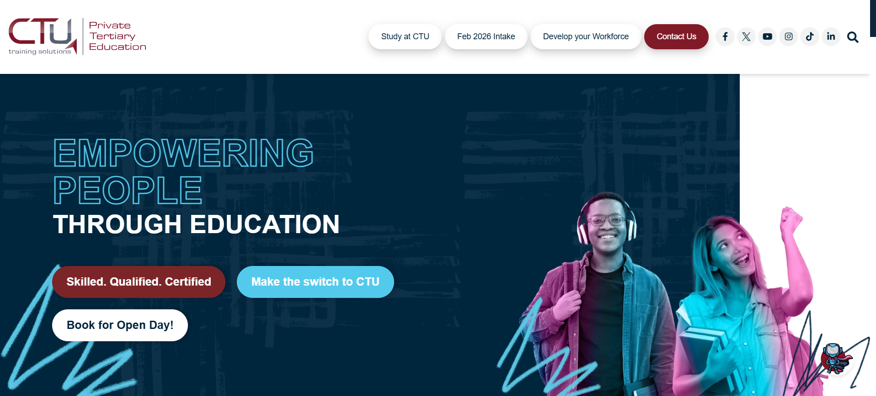

[CTU TRAINING SOLUTIONS WEBSITE HERE](https://www.ctutraining.ac.za/)

**Objective:**  
Your goal is to **recreate the CTU Training Solutions homepage from scratch** using **HTML, CSS, and official CTU assets (logo, icons, and images)**. The new design should be **modern, responsive, and user-friendly**, while still reflecting the **CTU brand identity**.

**Reference:**  
You must use the **current CTU Training Solutions website** as your reference for:

* Layout structure (sections, menus, footer, etc.)
* Colour scheme and typography
* Official CTU logo and images

*You are* ***not allowed to copy the source code*** *from the official website instead; you should* ***build everything manually*** *using your own code.*

**Requirements**

1. **Homepage Only:**  
   Develop a single webpage named index.html that represents the CTU homepage.
2. **Assets:**
   * Use the **official CTU logo** and other **images/icons** from the CTU website only.
   * Place all assets inside an images/ folder.
3. **Design & Layout:**
   * Include a **navigation bar** with links (Home, About, Courses, Campuses, Contact).
   * Add a **hero section** with a banner or background image.
   * Include **content sections** such as:
     + About CTU
     + Popular Courses or Programs
     + Campus Information
     + Contact/Call-to-Action (CTA)
   * Create a **footer** with copyright and social links.
4. **Technical Requirements:**
   * The project must include:
     + index.html
     + style.css
     + images/ folder
   * Use **semantic HTML5 structure** (<header>, <main>, <section>, <footer>, etc.).
   * Apply **CSS Flexbox or Grid** for layout.
   * Ensure the design is **responsive** (works on mobile and desktop).
5. **Submission:**
   * Compress your entire project folder (including all files and subfolders) into a .zip file.
   * File name example: CTU_Homepage_Redesign_YourName.zip
   * Submit the zip file via your class portal or as instructed by your facilitator.

**Project Criteria**

|  |  |
| --- | --- |
| **Criteria** | **Description** |
| Structure | Proper use of HTML tags and layout |
| Styling | Use of CSS, color theme, and responsiveness |
| Branding | Correct use of CTU logo and brand elements |
| Creativity | Original layout and interactive elements |
| Submission | All files correctly included and zipped then send to the facilitator on teams |